**Mono Apartments**

**Integrity Test Runsheet**

**V1.1 - Iteration 1.**

22 March 2023

Prepared for Mentors

Prepared by Team OneTen.

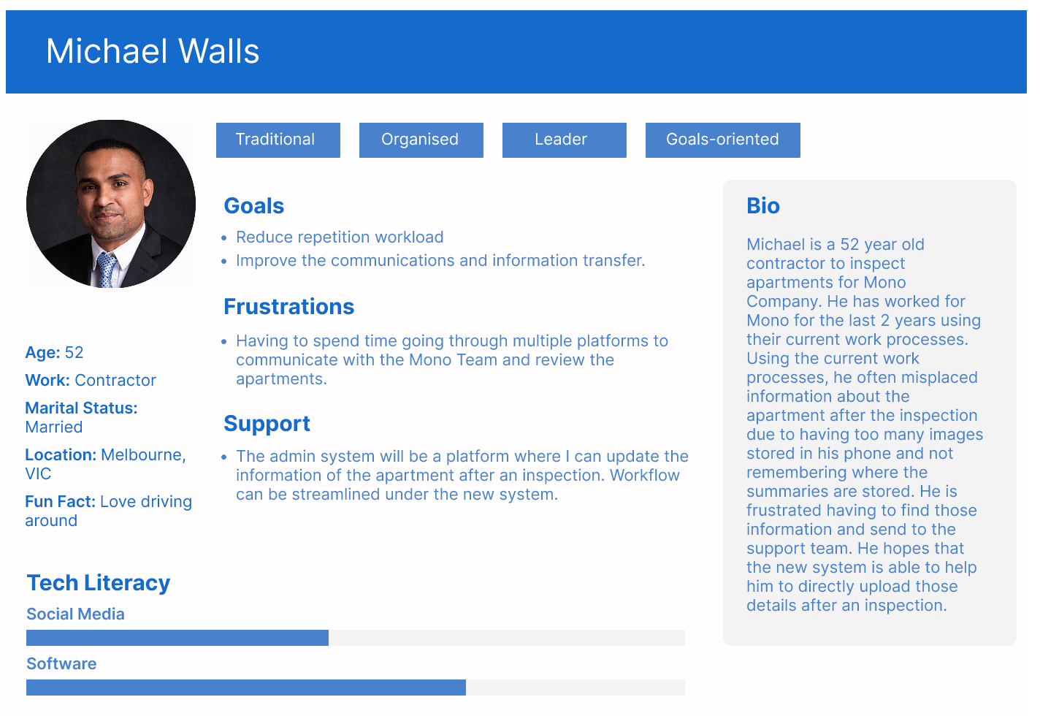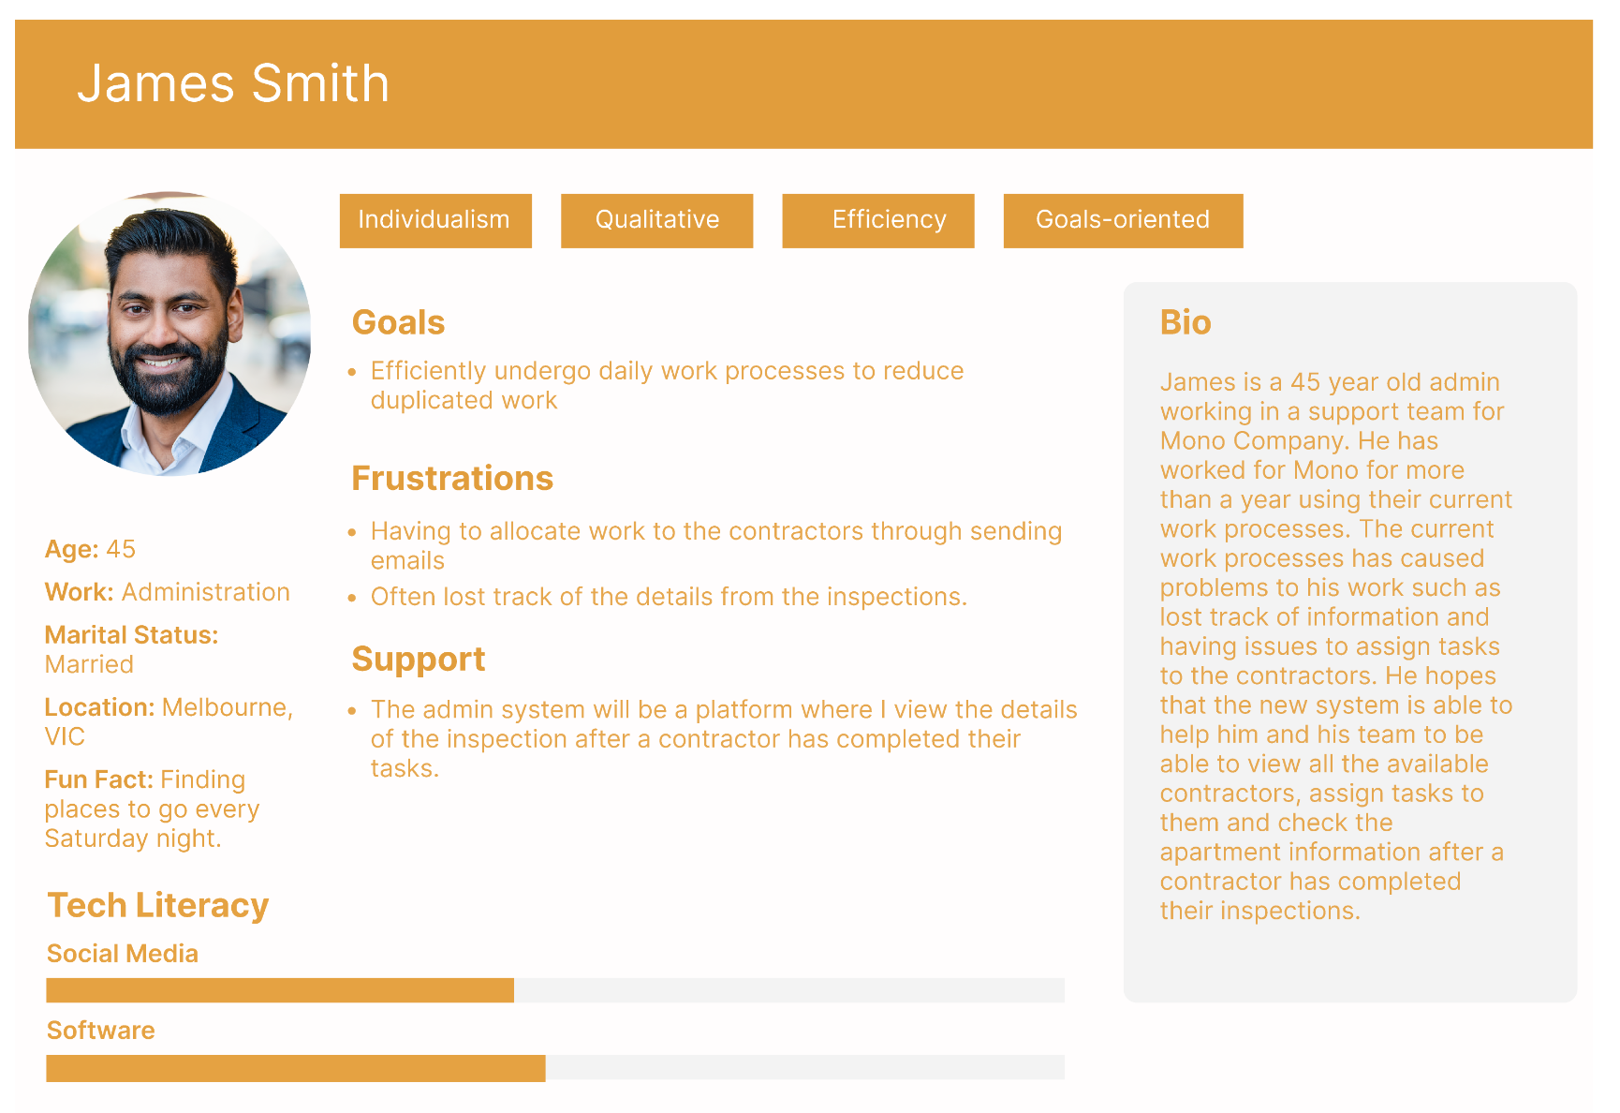

| URL | https://production.u22s2110.monash-ie.me/ |
| --- | --- |
| Login Username/Email | Contractor: root@example.com  Admin: root1@example.com |
| Password | team110 |

# Key System Notes

1. Login to Mono system on the login page under ‘Team Member’ at the bottom of the website.
2. Using the given credentials to access the system
3. James is the Admin from the Mono team and Michael is the contractor who works for Mono.
4. James as the admin can view/add/edit/delete the list inspections on the system
5. James as the admin can view/add/edit/delete the users and users’ information
6. James as the admin can view/add/edit/delete the inspection image
7. Michael as the contractor cannot add/edit/delete other users information
8. Michael as the contractor can add images in the inspection page.